**Wayside (Hardware) - Installation Manual**

**Lillian Jones**

### **Part I: Install Libraries**

1. Ensure that PyQt5 is installed on the machine: “pip install pyqt5”
2. Install pySerial on the device: “pip install pyserial”

### **Part II: Enable Serial Communication**

1. Configure the USB-to-Serial adapter on the Raspberry Pi 4 pins as follows:
   1. White = GPIO 14 (TXD)
   2. Green = GPIO 15 (RXD)
   3. Black = Ground

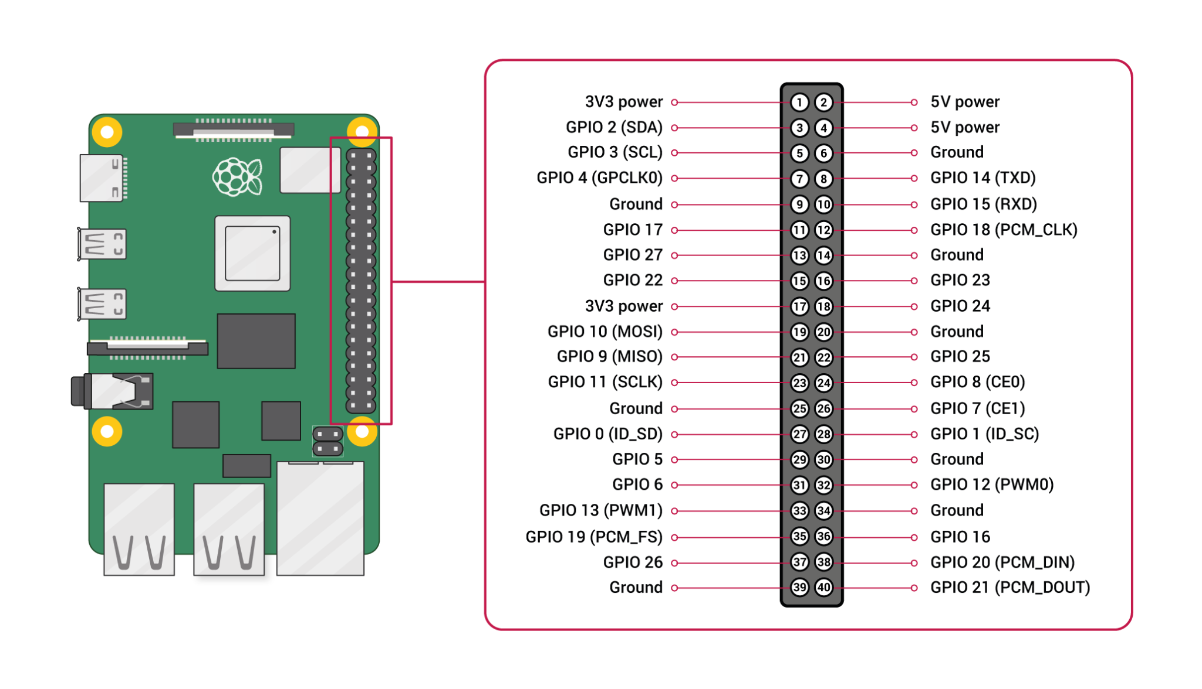

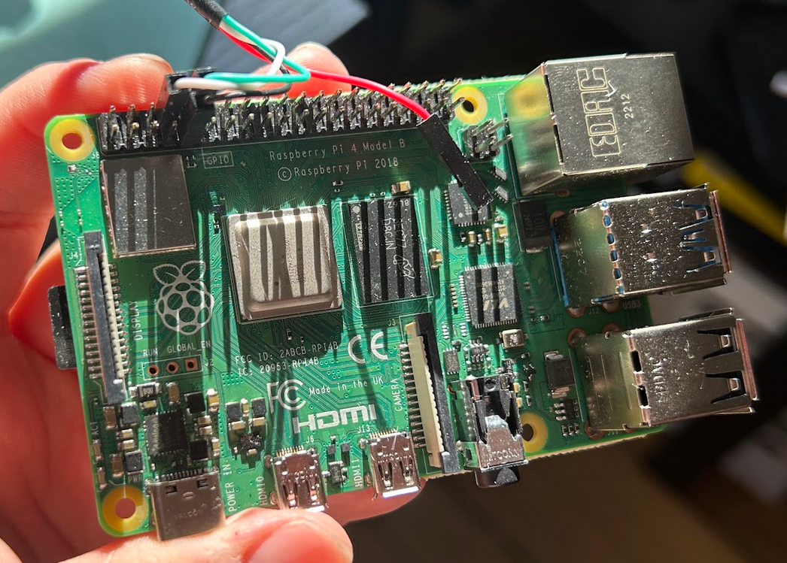

1. Plug the other end of the adapter into the USB port on the computer.
2. Follow instructions to install appropriate drivers for the hardware: <https://learn.adafruit.com/adafruits-raspberry-pi-lesson-5-using-a-console-cable/software-installation-windows>
3. Check “Device Manager” on the machine to determine which COM port corresponds to hardware. Change this accordingly within the code.

### **Part III: Connect Remotely to Raspberry Pi 4**

1. Install VNC Viewer to view PLC File Upload UI: <https://www.realvnc.com/en/connect/download/viewer/>
2. Run UI with Visual Studio Code and upload appropriate PLC file

### **Part IV: Set-Up/Operate Module**

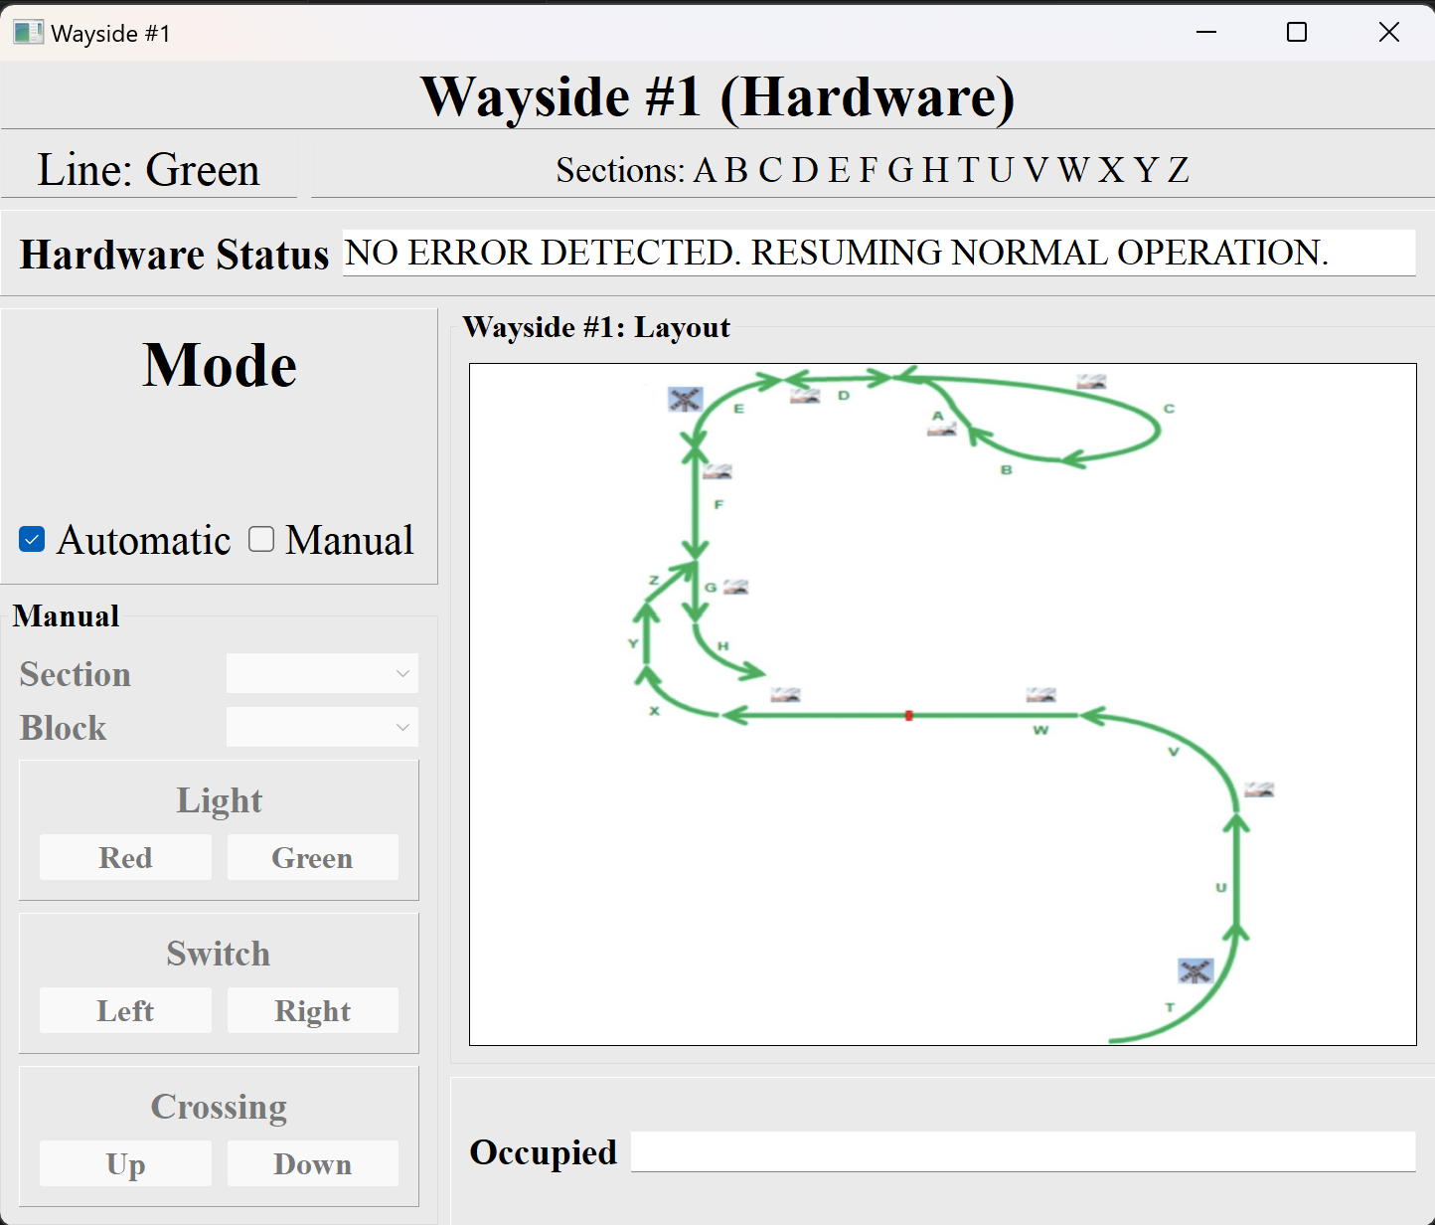

*Wayside #1 - UI*

1. The wayside module begins in automatic operation. This means that a valid PLC file must be uploaded to the Raspberry Pi 4 prior to train dispatch. Do this by completing the following steps:
   1. Follow all previous instructions to establish serial communication and connect remotely to RPi.
   2. Run “piUI.py” file on the Raspberry Pi 4. After doing this, a dialogue box will open, prompting the user to upload a PLC file. Find the desired file within the machine’s directory, select the file, and click “Open”. **Do not close out of the dialogue box after this step.** No more work is required on the Raspberry Pi.

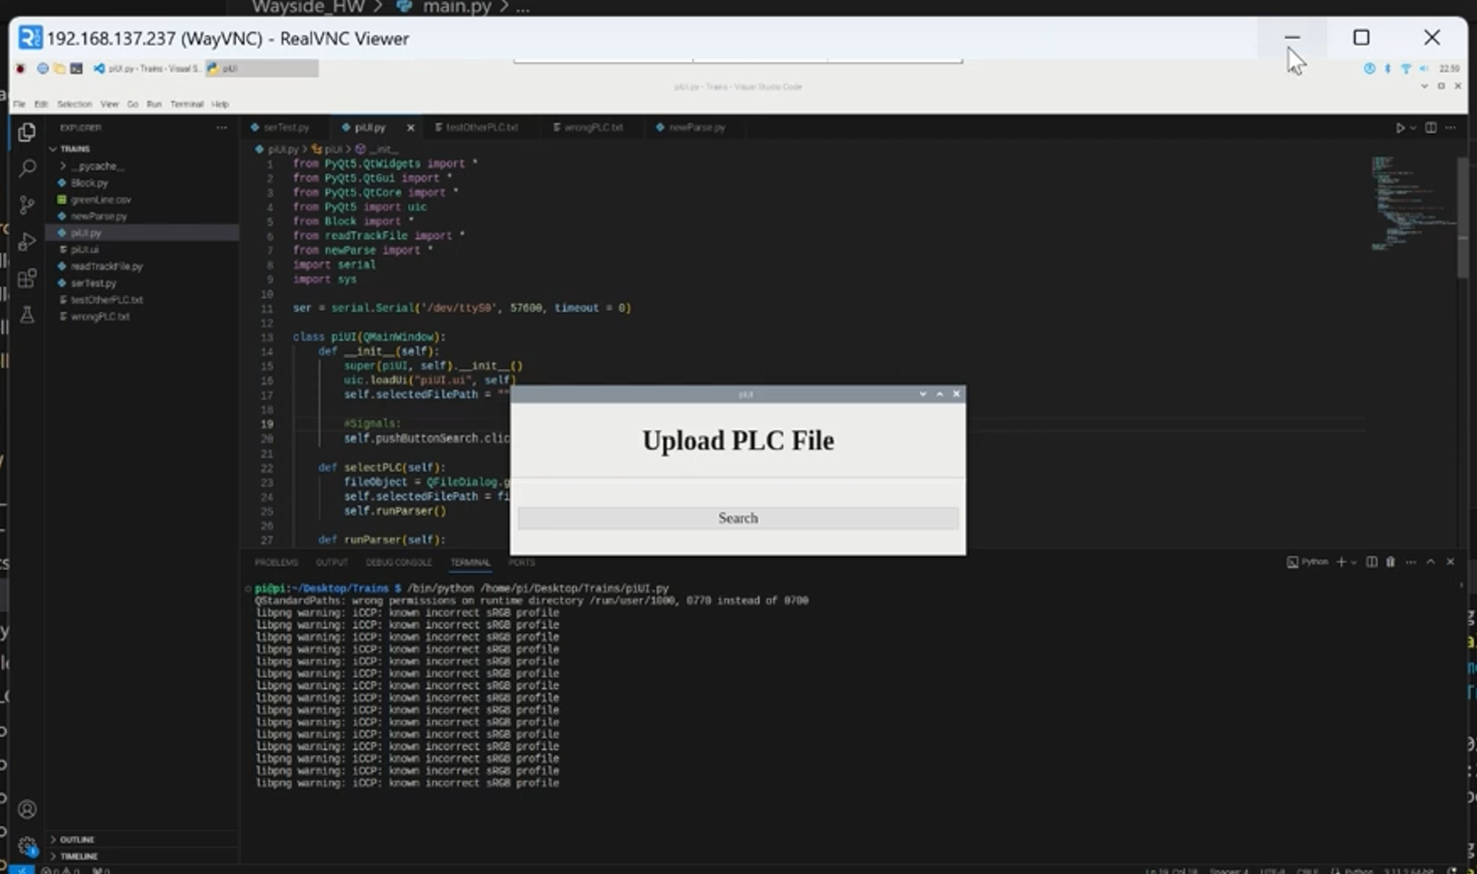

*Dialogue box seen on RPi UI*

1. After the PLC file is uploaded, the module will respond to block occupancies automatically as the main simulation is run. No input is required from the PLC programmer.
2. If the user wishes to put the train into manual operation, select the corresponding checkbox. This will allow block attributes to be changed by simply selecting the block.

### **Part V: FAQ**

* Why are errors being detected in automatic mode?
  + The PLC file was not valid, or it was never uploaded. Please try uploading an accurate, properly-formatted PLC file.
  + Another possible problem is that serial communication was not established correctly. Re-trace the steps in Part II to ensure accuracy.
* How can I ensure that switch, light, and crossing states are being calculated correctly in automatic mode?
  + Switch, light, and crossing states are reflected in the Track Model UI. Please refer to this UI for confirmation.
* Is there protocol in-place for preventing collisions between trains? Does this protocol apply to block closures?
  + Yes. Per-block authority is calculated every time a new block occupancy is detected. Two trains will never collide, as per this calculation. Closed blocks are interpreted as occupancies by this module, so the same protocol applies.